UNIT 6: THE YOUNG PIONEERS CLUB

READ
Ho Chi Minh Communist Youth Union is an organization for Vietnamese youth from 15 to 30 years of age. The Union builds good character, love for the nation, and encourages good citizenship, soft skills and personal fitness.
The Union was founded on March 26, 1931, by the beloved President Ho Chi Minh. It had different names over the years. One of its first names was the ‘Vietnam Communist Youth Union’. In December 1976, it was officially named as it is called today: Ho Chi Minh Communist Youth Union. However, people normally use the name 'The Youth Union' for short.
The Youth Union, together with other youth organizations such as the Young Pioneers Organization, the Vietnam Youth Federation, the Vietnam Students Union, often hold social activities such as Helping the Handicapped, Cleaning the Environment, Green Summer Volunteers Campaign, and other similar movements. These activities aim to help the young develop their public awareness and form their personality.
Ever since the Union was founded, its aims and principles, established by President Ho Chi Minh, have been the guidelines for the young Vietnamese people of today and tomorrow.
Vocabulary:
- union /ˈjuː.nj.ən/ (n): liên hiệp, liên minh, sự kết hợp
- Ho Chi Minh Communist Youth Union: Đoàn Thanh niên Cộng sản Hồ Chí Minh
- organize /ˈɔːr.ɡən.aɪz/ (v): tổ chức, cấu tạo, thiết lập – organization /ˌɔːr.ɡən.əˈzeɪ.ʃən/ (n): sự tổ chức – organizer (n): người tổ chức
- encourage /ɪnˈkɝː.ɪdʒ/ (v): động viên, khuyến khích – encouragement /ɪnˈkɝː.ɪdʒ.mənt/ (n): sự động viên – encouraging /ɪnˈkɝː.ɪ.dʒɪŋ/ (adj) – enouragingly /ɪnˈkɝː.ɪ.dʒɪŋ.li/ (adv)
- citizenship /ˈsɪt̬.ə.zən.ʃɪp/ (n): quyền công dân, ý thức công dân
- soft skills: kỹ năng mềm
- found /faʊnd/ (v): thành lập, sáng lập, đặt nền tảng
- beloved /bɪˈlʌvd/ (adj): được yêu mến
- official /əˈfɪʃ.əl/ (adj): chính thức – officially /əˈfɪʃ.əl.i/ (adj)
- the Vietnam Youth Federation: Hội liên hiệp thanh niên Việt Nam
- the Vietnam Students Union: Hội sinh viên Việt Nam
- social activities: các hoạt động xã hội
- Green Summer Volunteers Campaign: chiến dịch mùa hè xanh
- movement /ˈmuːv.mənt/ (n): hoạt động, hành động
- aim /eɪm/ (n): mục đích
- public awareness: ý thức cộng động
- personality /ˌpɝː.sənˈæl.ə.t̬i/ (n): nhân cách, tính cách
- principle /ˈprɪn.sə.pəl/ (n): nguyên tắc, nguyên lý
- guideline /ˈɡaɪd.laɪn/ (n): nguyên tắc chỉ đạo, đường lối chỉ đạo
Task 1. Fill in the missing information.
(Hãy điền thông tin còn thiếu.)
a) The Youth Union was founded in____________
b) In__________ the Youth Union was officially named as it is called today.
c) The Youth Union’s activities aim to help the young develop_____________________
d) Its aims and principles have been_______________ for the young Vietnamese people of today and tomorrow.
Suggested answer:
a) The Youth Union was founded in 1931.
b) In 1976 the Youth Union was officially named as it is called today.
c) The Youth Union's activities aim to help the young develop their public awareness and form their personality.
d) Its aims and principles have been the guidelines for the young Vietnamese people of today and tomorrow.
Task 2. Answer. Then write the answers in your exercise book.
(Trả lời. Sau đó viết các câu trả lời vào trong vở bài tập.)
a) At what age can one join the Youth Union?
b) When was the Youth Union founded?
c) What is the complete name of the Youth Union?
d) Can you name some social activities of the Youth Union?
e) What do these activities aim to help?
f) Who established the guidelines for the Vietnamese youth?
g) (open question - optional)
What names have the Youth Union had over the years?
Suggested answer:
a) From 15 to 30 years of age can join the Youth Union.
b) Union was founded on March 26, 1931.
c) Ho Chi Minh Communist Youth Union is the complete name of the Youth Union.
d) These are Helping the Handicapped, Cleaning Environment, Green Summer Volunteers Campaign, ...
e) These activities aim to help the young develope their public awareness and form their personality.
f) President Ho Chi Minh established the guidelines for the Vietnamese Youth.
g) The Youth Union had different names over the years. Its name was "Vietnam Communist Youth Union", "Ho Chi Minh Communist Youth Union", ...

LANGUAGE FOCUS
Present tense with future meaning: S + V(s,es)
- Diễn tả sự việc sẽ xảy ra theo lịch trình, thời gian biểu rõ ràng như giờ tàu, máy bay chạy.
Ví dụ:
- The train leaves at 5 pm today. (Tàu sẽ rời đi vào lúc 5h chiều ngày hôm nay.)
- The flight starts at 9 am tomorrow. (Chuyến bay sẽ bắt đầu vào lúc 9h sáng ngày mai.)
EXERCISES:
- The concert _____________ at 7 p.m and _____________ at 9 p.m. (start/ finish)
- Her art gallery______________ on August 10th. (open)
- ________ the train ________ at 10.30 tomorrow? (leave)
- The lecture ______________ at 7.30. (start)

Task 1. Work with a partner. Ask and answer questions about Y&Y Spring activity program.
(Cùng với bạn em, hãy hỏi và trả lời câu hỏi về chương trình hoạt động mùa xuân của Đoàn Đội.)
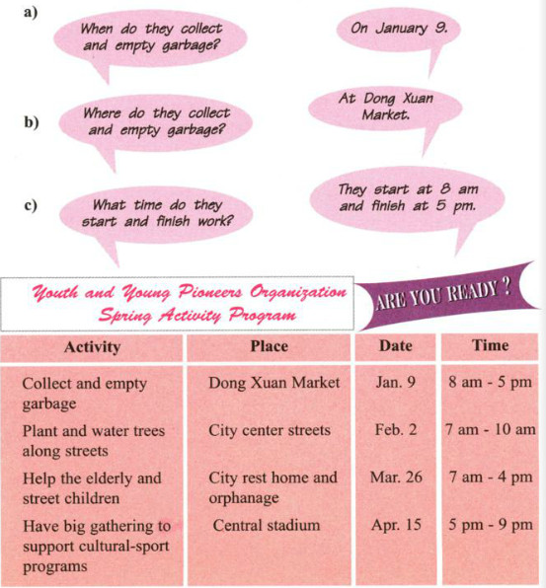
1.
- When do they plant and water trees along streets?
=> On February 2.
- Where do they plant and water trees along the streets?
=> On the City center streets.
- What time do they start and finish work?
=> They start at 7 am and finish at 10 am.
2.
- When do they help the elderly and street children?
=> On March 26.
- Where do they help the elderly and street children?
=> At the City rest home and orphanage.
- What time do they start and finish work?
=> They start at 7 am and finish at 4 pm.
3.
- When do they have big gathering to support cultural-sport programs?
=> On April 15.
- Where do they have big gathering to support cultural-sport programs?
=> In the Central stadium.
- What time do they start and finish work?
=> They start at 5 pm and finish at 9 pm.
Gerund (V.ing) (danh động từ)
- VERB + GERUND.
Tiếng Anh có một số động từ có động từ theo sau ở dạng danh động từ (gerund) như : MIND (quan tâm), AVOID (tránh), MENTION (quan tâm). FINISH (làm xong), PRACTISE (thực hành), POSTPONE (hoãn lại), IMAGINE (tưởng tượng), CONSIDER (xem xét), ENJOY (thưởng thức, thích thú), ADMIT (nhận), SUGGEST (đề nghị), LIKE (thích), DISLIKE (không thích), HATE (ghét), LOVE (ưa thích, yêu). CAN’T HELP (không thể không...), CAN’T BEAR CAN’T STAND (không thể chịu được),...
e.g.: His son enjoys reading picture-books. (Con trai ông ấy thích đọc sách truyện tranh.)
They postponed building a new school in the area. (Họ đã hoãn xây một trường mới ở khu vực này.)
- Động từ theo sau giới từ luôn luôn ở dạng danh động từ (gerund),
e.g.: He’s interested in speaking English. (Anh ấy thích nói tiếng Anh.)
His brother gave up smoking. (Anh của anh ấy đã bỏ hút thuốc.)
- Những động từ như : NEED (cần), REQUIRE (cần), DESERVE (xứng đáng), WANT (cần),... có động từ theo sau ở dạng danh động từ (gerund) khi chủ từ là từ chỉ đồ vật hay sự việc và có nghĩa bị động (passive meaning).
e.g.: This room needs repainting. (Phòng này cần được sơn lại.)
Your hair requires cutting. (Tóc bạn cần được cắt.)
EXERCISES: Put the verbs in the brackets into the correct form:
- We decided ___________ (buy) a new car.
- They’ve got some work __________ (do).
- Peter gave up __________ (smoke) .
- He’d like __________ (fly) an aeroplane.
- I enjoy ___________ (write) picture postcards.
- Do you know what _________ (do) if there’s a fire in the shop?
- Avoid __________ (make) silly mistakes.
- My parents wanted me __________ (be) home at 11 o’clock.
- I dream about ___________(build) a big house.
- I’m hoping __________ (see) Lisa.
- Would you mind ___________ (show) me how ___________ ( send) an email?
- The children prefer ____________ ( watch) TV to _____________ ( read) books
Task 2. Work with a partner.
(Hãy làm việc với bạn em.)
a) Look at the table. Talk about our friends’ hobbies.
(Em hãy nhìn bảng sau và nói về sở thích của bạn em.)
A: Ba loves playing soccer, but he doesn't like washing up
B: Lan doesn’t like playing soccer and she doesn't like washing up, either.
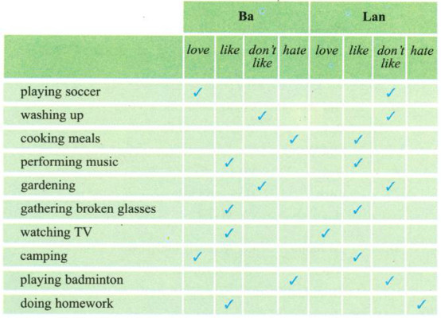
b. Copy the table into your exercise book. Then complete it with information about you. Next ask and answer questions with your partner.
(Hãy sao bảng trên vào vở bài tập của em rồi hoàn thành nó bằng những thông tin về bản thân em, sau đó hỏi và trả lời câu hỏi với bạn em.)

Suggested answer:
a.
A: Ba loves playing soccer, but he doesn't like washing up.
B: Lan doesn't like playing soccer and she doesn’t like washing up, either.
A: Ba hates cooking meals, but he likes performing music.
B: Lan likes cooking meals and she likes performing music.
A: Ba doesn't like gardening and Lan doesn't, either.
B: Ba likes gathering broken glasses and Lan does, too.
A: Ba likes watching TV and he loves camping, too.
B: Lan loves watching TV and she likes camping, too.
A: Ba hates playing badminton, but he likes doing homework.
B: Lan doesn't like playing badminton and she hates doing homework.
b.
1. A: Do you like playing soccer?
B: No. I hate it. What about you?
A: Yes. I love playing soccer.
2. A: Do you like washing up?
B: Yes. I love it. What about you?
A: No. I hate it.
3. A: Do you like cooking meals?
B: No. I hate it. What about you?
A: Yes. I love cooking.
4. A: Do you like performing music?
B: Yes. I love it. What about you?
A: No. I hate it.
5. A. Do you like doing gardening?
B: No. I hate it. What about you?
A: Yes. I love gardening.
6. A: Do you like gathering broken glasses.
B: No. I hate it. What about you?
A: Yes. I love gathering broken glasses.
Task 3. Work with a partner.
(Hãy làm việc với bạn em.)
a. Use the expressions in the box to ask for a favor. Then practice the dialogues with a partner.
(Dùng các diễn đạt cho trong khung để hỏi xin sự giúp đỡ, sau đó luyện nói với bạn em.)
help me with this math problem
buy a ticket
water the flower in the garden
take me across the road
A.
Woman: Can/Could you help me, please?
Man: Yes, certainly.
Woman: Can you _________?
B.
Old Woman: Could you do me a favor?
Boy: What can I do for you?
Old Woman: Can you _________?
C.
Boy: I need a favor.
Girl: How can I help?
Boy: Could you ________?
D.
Grandpa: Can you help me, please?
Niece: Yes. Of course.
Grandpa: Can you __________ ?
b. Use useful expressions in the boxes on page 55 to complete the dialogues. Then practice the dialogues with a partner.
(Hãy dùng các diễn đạt cho trong khung ở trang 55 để hoàn thành các hội thoại sau rồi luyện nói với bạn em.)
Asking for favors | Responding to favors
Can/Could you help me, please?  Could you do me a favor?  I need a favor.  Can/Could you ... ? | Certainly/ Of course/ Sure  No problem.  What can I do for you?  How can I help you?  I'm sorry. I'm really busy.
Offering assistance | Responding to assistance
May I help you?  Do you need any help?  Let me help you. | Yes/No. Thank you.  Yes. That’s very kind of you.  No. Thank you. I’m fine.
A: __________ help you?
B: Yes. Thank you. Could you fill in this form for me?
A: ____________ any help?
B: No. Thank you. I’m fine.
A: Oh. This bag is heavy
B: Let____________ .
A: Yes. That’s ________ of you.
Suggested answer:
a)
A:
Woman: Can/ Could you help me, please?
Man: Yes, certainly.
Woman: Can you buy a ticket?
B:
Old woman: Could you do me a favor?
Boy: What can I do for you?
Old woman: Can you take me across the road?
C:
Boy: I need a favor.
Girl: How can I help?
Boy: Could you help me with this math problem?
D.
Grandpa: Can you help me, please?
Niece: Yes. Of course.
Grandpa: Can you water the flowers in the garden?

